**Project Outline**

Street Friends

1. **Project Description**

Street Friends will help people get in touch with their neighbors based on their residential address.

1. **Problem Addressing**

Helps users take the first step in virtually getting to know their neighbors, helping them to organize gatherings and share information securely.

1. **Platform**

Mobile and web applications.

1. **Front/Back-end Support**

Front-end: Adalo’s built-in tools for UI design. Adalo's front-end is based on React.

Back-end: The database is managed by Adalo’s back-end services.

Adalo's back-end is based on a mix of technologies but primarily Node.js.

**5: Security**

Standard implementation, such as HTTPS, data encryption, and user authentication, is provided by Adalo.

**Data Structure**

**Design (Wireframes)**

Login Communication Chat

**Navigation Methodology (User Interface)**

1. **Homepage Navigation:** Users access the key sections via the main menu and search bar.
2. **User Authentication:** Signup/Login options provide for account access.
3. **Browsing:** Users browse, filter, and view posts shared by other users near their neighborhood.
4. **Posting:** Users easily post stories with their neighbors guided by app submission.
5. **Profile Page:** Users can view other users’ posts.
6. **Messaging System:** Users communicate with friends via inbox.
7. **Account Management:** Users access profile settings and history.

**Functionality**

* **User Authentication:** Feature ensures that only users with verified location can access the site.
* **Discovering:** Feature allows users to browse and contact their local neighbors based on their location.
* **Posting:** Allows users to upload pictures of the memories they want to share with their neighbors.
* **Messaging System:** Facilitate communications between users.

**Requirements**

1. **User sign-up:**
   1. User reaches the login page.
   2. User clicks “Sign Up” and enters their email into the database.
   3. User receives an email with a link to set up their password and location.
   4. If email is invalid, user does not receive email.
   5. User clicks the link and is prompted with password requirements.
   6. User account is created.
2. **User Login:**
   1. User reaches the login page.
   2. User enters their email and password.
   3. The system compares the entered credentials to the saved log-ins in the database.
   4. The system will ask a secret question for double verification.
   5. If correct, the user is granted access.
   6. If incorrect, the user can try again.
3. **Browsing:**
   1. User reaches the login page.
   2. Users enter their email and password.
   3. User logs into the homepage.
   4. User scrolls to view neighbors’ memories.
4. **Posting Items:**
   1. User reaches the login page.
   2. User enters their email and password.
   3. User logs in.
   4. User clicks on the “Create post” button.
   5. User is presented with an upload option for an image and a text box for title and description.
   6. The new post appears within the Homepage to the user with a correlated location.
5. **Messaging:**
   1. User reaches the login page.
   2. User enters their email and password.
   3. User logs into the conversations.
   4. User navigates to their message’s notification inbox.
   5. User responds to the messages.

**Non-Functional Requirements:**

* **Usability:** Must be reliable and user-friendly.
* **Compatibility:** The application is compatible with the latest phones.
* **Performance:** Must perform well under load with multiple users and stress.
* **Security:** Personal information, communication, and transactions must be secure.

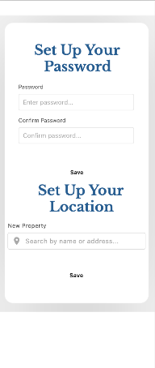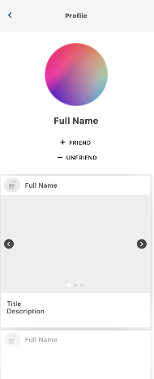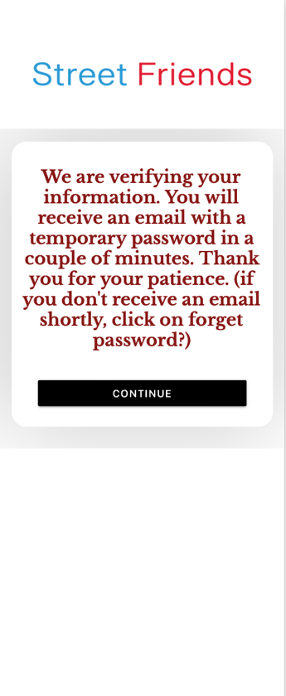

**Final Designs**

**GitHub**

https://github.com/Trochej15/Street-Friends?tab=readme-ov-file#street-friends